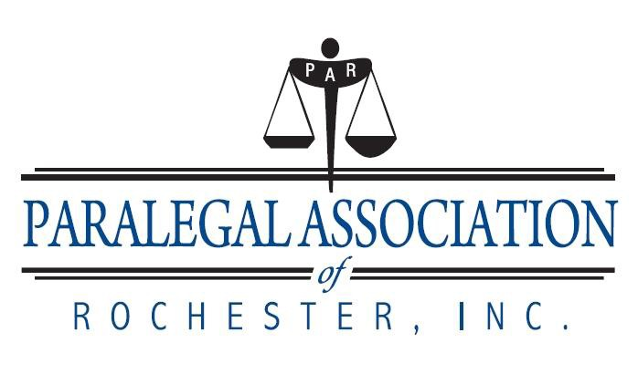

NEW MEMBER APPLICATION
Check One
VOTING: Any person employed as a paralegal, no less than 20 hours per week, who performs substantive legal work that requires knowledge of legal concepts and is customarily, but not exclusively, performed by a lawyer, may join the Association as a Voting Member. Said person may be retained or employed by a lawyer, law firm, government agency, court or other entity. Voting membership requires that a paralegal’s work be supervised by an attorney.

NON-VOTING: Any person who would otherwise qualify as a Voting Member as defined above, except length of work experience is insufficient, and/or currently unemployed (for mare than 90 days) and/or works less than twenty hours per week. Any paralegal who is currently not employed as a paralegal for whatever reason, but who would otherwise qualify as a Voting Member as defined above, may join as a Non-Voting Member.

STUDENT: Current students enrolled in a paralegal program or other related/formal educational program in an accredited college or university may make application to the Membership Committee, and upon being approved, and dues paid in full may become a Student Member. (Student Member shall not be entitled to vote.)

Name:

Email:

Home Address: City: State: Zip Code:

Phone number: ________________

Where would you like your mailings sent? (home or work):

Current Employer: Supervisor:

Work Address: City: State: Zip Code: _ Work Phone: Work Fax:
Your Title: Areas of Specialization:

Hire Date: Total Years Employed as a Paralegal:

Is your work supervised by an Attorney:

Please describe your current job responsibilities in detail:

If less than one year at current employment:

Previous Employer: Supervisor:

Work Address: City: State: Zip Code:

Work Phone: Work Fax:

Your Title: Areas of Specialization:

Paralegal Training: Structured – Yes or No

Name of Institution: Degree:

Address: City: State: Zip Code:

Are you currently a student?: Graduation/Anticipated Graduation Date:

Do you do secretarial work? If yes, what percentage of your time is spent on client matters? Is your time charged to clients?

Please make any comments that you believe will assist the Membership Committee in evaluating your application:

Please provide us with the name and contact information of an individual that we may contact in order to obtain any additional information the Membership Committee may need.

Choose a committee(s) to serve on:

Special Events
Fundraising
Wherever Needed

BY INITIALING HERE YOU AGREE TO THE FOLLOWING: ( ) ( )
Initials Date

Membership Annual Dues (which include membership dues for NFPA): Voting Member $60.00 Non-Voting Member $50.00 Student Member $30.00
PAR’s annual membership renewal occurs in April of each year.

Should you join after 1/1 and before 3/31 your dues will be prorated as follows: Voting Member $30.00 Non-Voting Member $25.00 Student Member $20.00
You will receive a renewal in April and at that time you will pay your full dues and your membership will run May to April thereafter.

MEMBERSHIP DUES ARE NOT DUE UNTIL YOU RECEIVE AN ACCEPTANCE LETTER FROM THE MEMBERSHIP COMMITTEE.

To read and agree to the NFPA Model Code of Ethics, go to http://www paralegals.org and click on “Positions and Issue” and “Ethics.”
Applications may be emailed as an attachment to: PARoc.Membership@gmail.com or mailed to Paralegal Association of Rochester, Inc.
Attn: Membership PO Box 20106
Rochester, NY 14602

CERTIFICATION: I hereby apply for membership in the Paralegal Association of Rochester, Inc. (“PAR”) and certify that this application is true and correct. I agree to be bound by the Model Code of Ethics and Professional Responsibility adopted by the National Federation of Paralegal Associations, Inc. (“NFPA”) and the By-Laws of PAR. I give consent to the Membership Committee to contact my present and/or former supervising attorney(s) for verification or clarification of this application.

Date:_
Signed:

The information contained in this application is subject to review by the Membership Committee of PAR and may be disseminated to PAR’s Board of Directors.
PAR is a member association of NFPA and, by virtue of joining PAR, you are a member of NFPA. A portion of your PAR dues is sent to NFPA for your membership in NFPA, which includes your National Paralegal Reporter subscription.
Checks returned to the Treasurer for non-sufficient funds, or any other reason, will be returned to the issuer for reimbursement of the face value of the check plus any fees incurred by PAR from its financial institution.

